Supplemental Material, Design S1 (Coffee Cherry Color Sorter)

Schematic

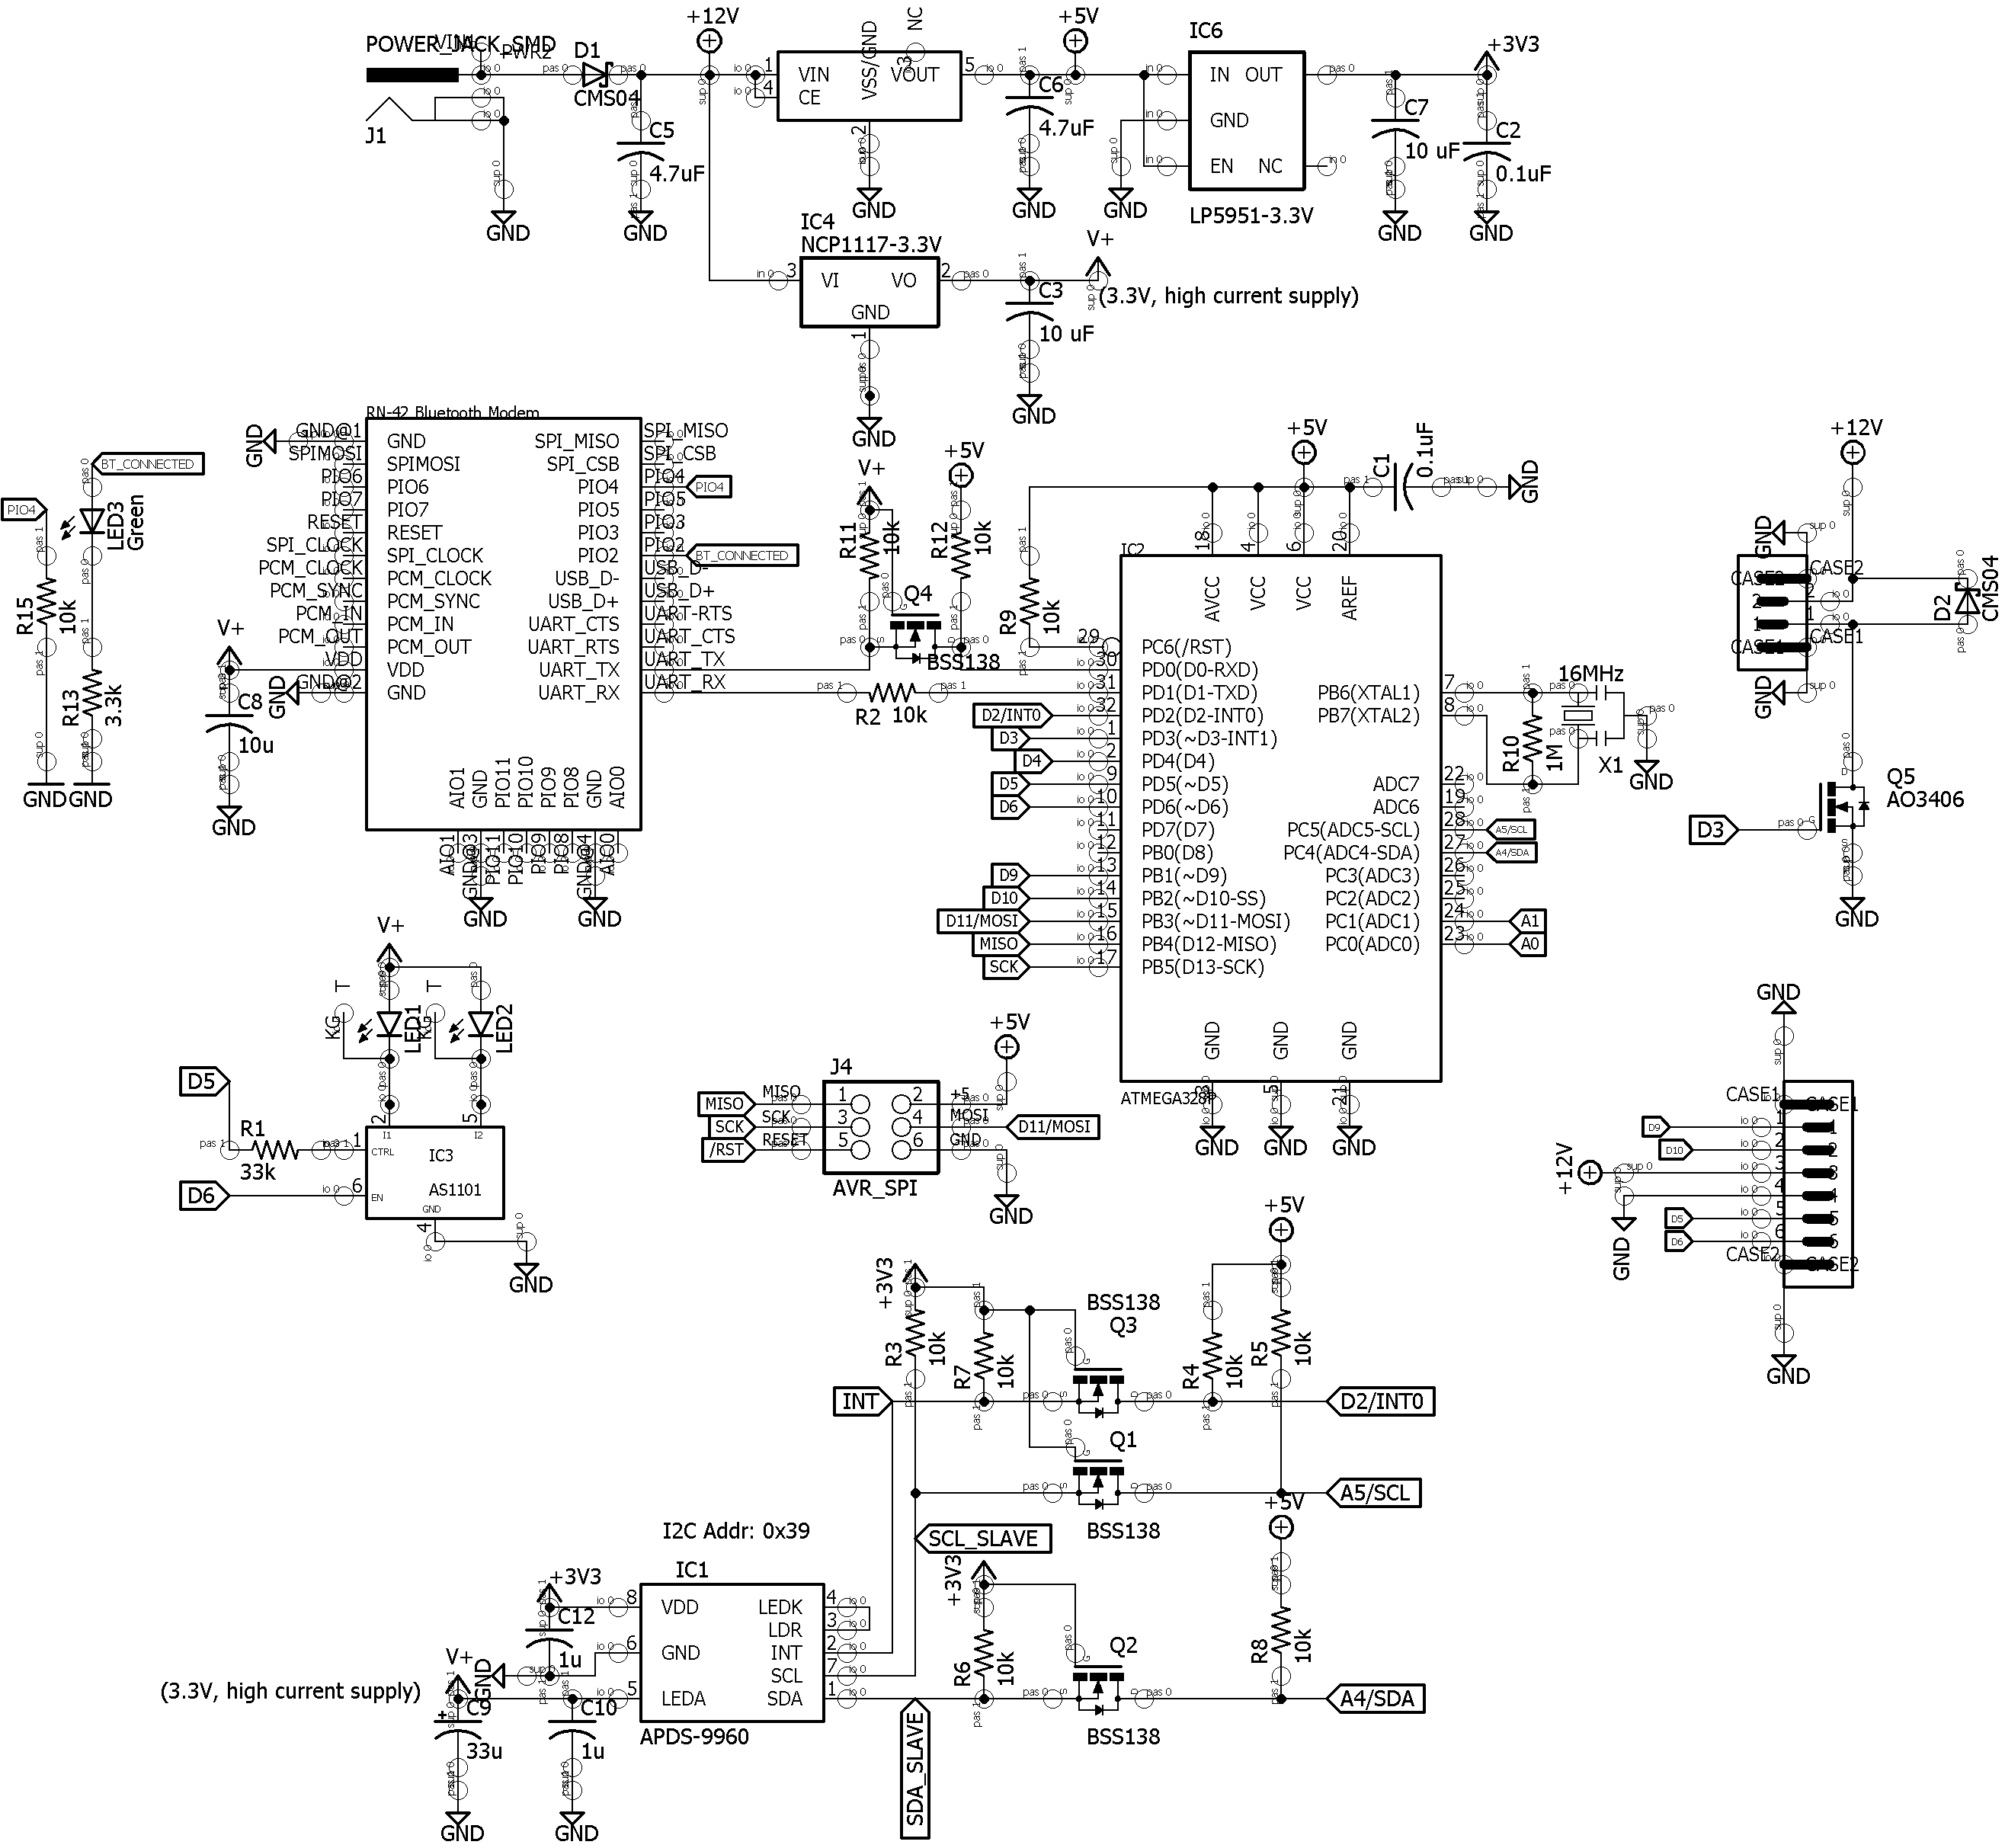

Layout

